**DAILY ONLINE ACTIVITIES SUMMARY**

|  |  |  |  |  |  |  |  |
| --- | --- | --- | --- | --- | --- | --- | --- |
| **Date:** | **12/06/2020** | | | | **Name:** | **Namratha C** | |
| **Sem & Sec** | **8th sem, A sec** | | | | **USN:** | **4AL16CS056** | |
| **Online Test Summary** | | | | | | | |
| **Subject** | | **BDA** | | | | | |
| **Max. Marks** | | **22** | | **Score** | | **30** | |
| **Certification Course Summary** | | | | | | | |
| **Course** | **What is Artificial Intelligence?** | | | | | | |
| **Certificate Provider** | | | **Aws training and certification** | **Duration** | | | **10mins** |
| **Coding Challenges** | | | | | | | |
| **Problem Statement: 1)Python program to remove duplicate elements from a list** | | | | | | | |
| **Status: Completed** | | | | | | | |
| **Uploaded the report in Github** | | | | **Yes** | | | |
| **If yes Repository name** | | | | **CODES (Namrathasonu)** | | | |
| **Uploaded the report in slack** | | | | **Yes** | | | |

Online Test Details:

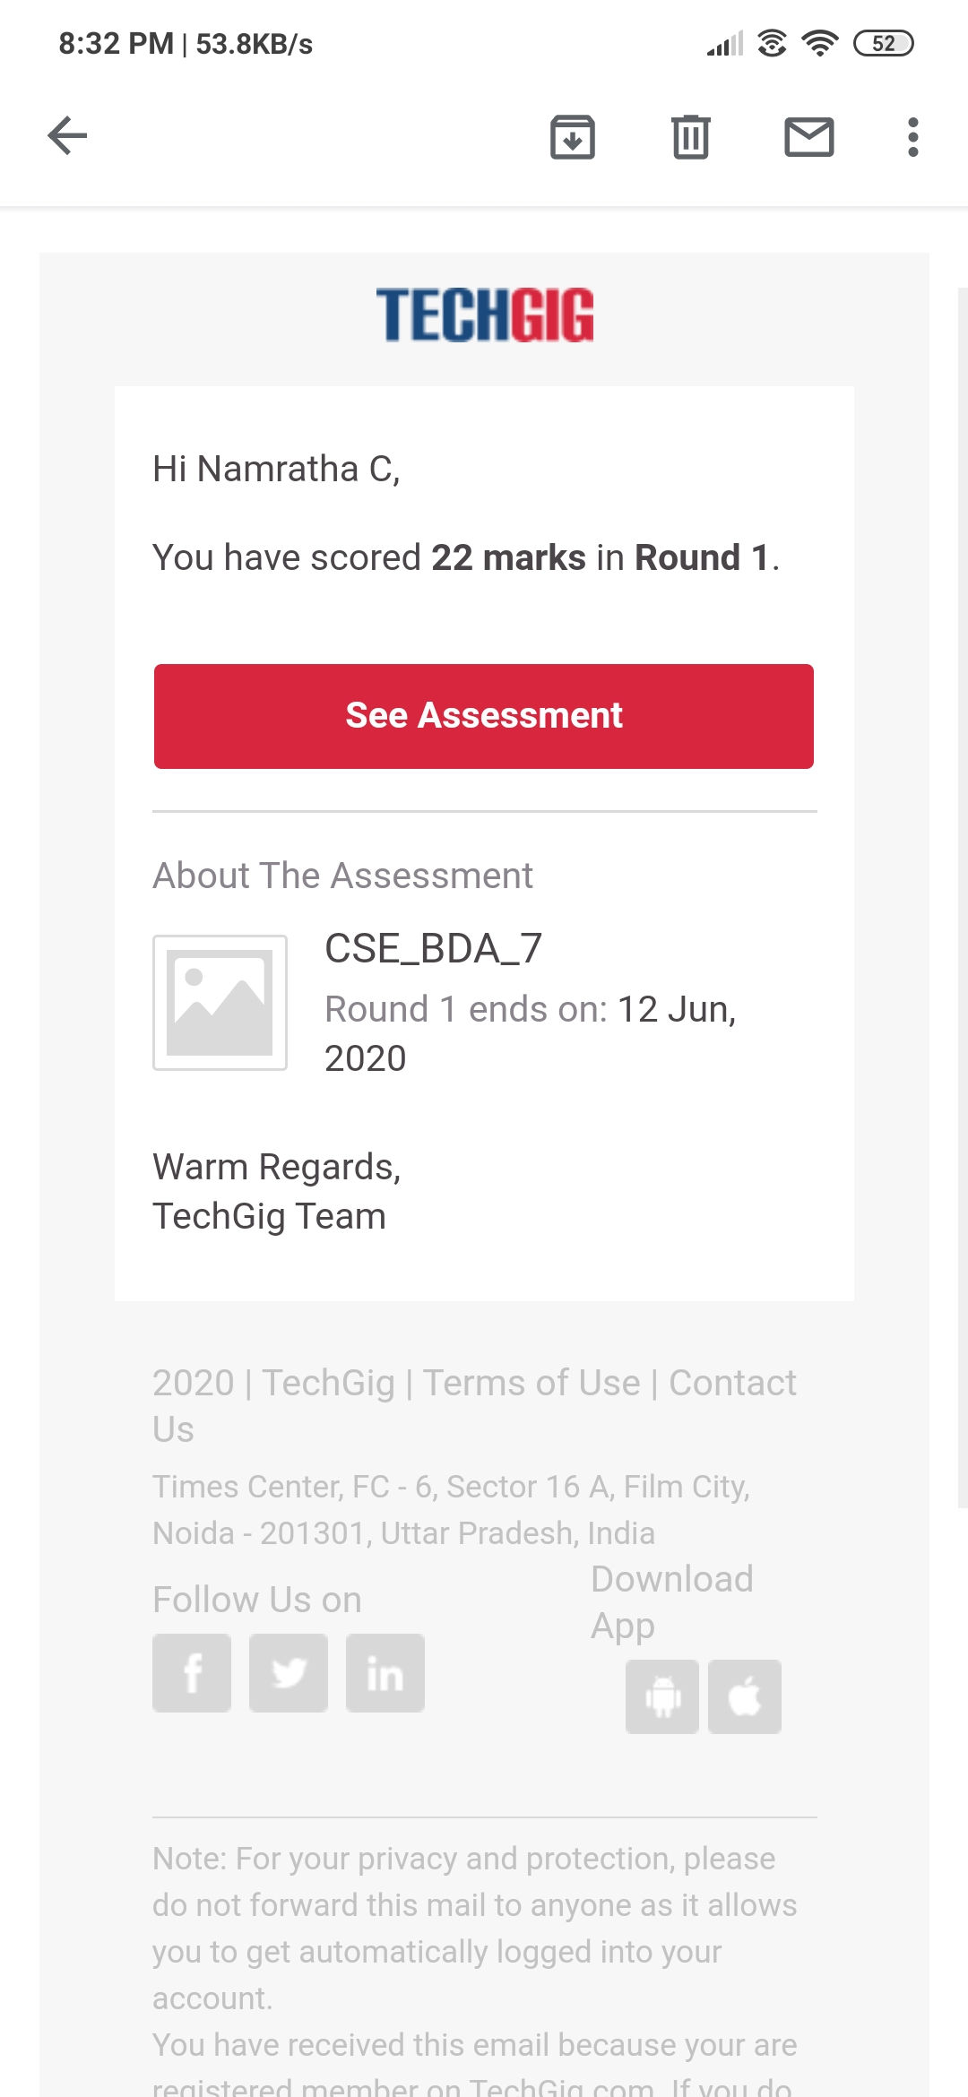

Certification Course Details:

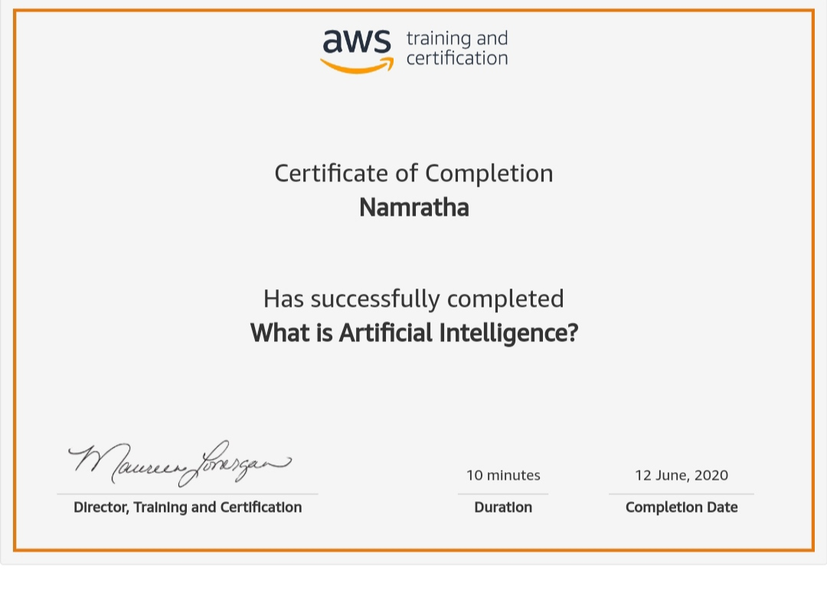

Coding Challenges Details:

1)

n = int(input())

elements = []

for i in range(0, n):

elements.append(int(input()))

result = list(sorted(set(elements)))

print(result)